These antireflection coatings were deposited having optimum thicknesses and the value of refractive index follows well known equation that was suggested in Ref. [8]: 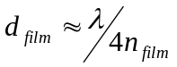, 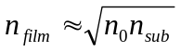, where n_{sub} and n_{film} are the refractive indexes of the substrate (Si, n_{sub} = 3.96) and the coating, respectively. Thus, the value of the refractive index of DLC coating to reach the minimum reflection and corresponding thickness of the film are 2.0 (at λ = 632 nm) and 70 nm, respectively.
8. J. Zhao, Martin A. Green. Optimized Antireflection Coatings for High-Efficiency Silicon Solar Cells. IEEE Transactions on Electron Devices, 38 8 (1991) 1925-1934.

